**Project 7 Coin Detection with OpenCV**

Name: Ramya Reddy Period: 4 Date: 3/24/22

Did you name your file l071.cpp (Lower case L, then 071)? Yes

Did you use OpenCV to detect coins? Yes

Did you test your code on terminal/gnu linux in c++11? Yes _____________________________________________________________________________________

What functions/methods from OpenCV did you use?

blur() – used to blur the source image

Canny() – used to do the Canny Edge detection

medianBlur() – used to additionally blur the grayscale image for Hough Transform

HoughCircles() – used to identify circles

imwrite() – used to make image files

imread() – used to read image file

cvRound() – used to round values

_____________________________________________________________________________________

What functions/methods from OpenCV did you experiment with but ended up not using?

GaussianBlur() – ultimately used medianBlur()

*CLI arguments key:*

-H High threshold used for Canny Edge detection

-L Low threshold used for Canny Edge detection

-F Name of source file

-KS Kernel size for Sobel operator for Canny Edge Detection

-MS Minimum separation between identifiable circles

-R Coefficient multiplied to high threshold for Canny Edge Detection

-MinR Minimum radius of circle

-MaxR Maximum radius of circle

-TC Minimum threshold for HoughCircles to identify circle

-MinQ Minimum radius for quarters

Run your code (the same code you submit) on the 3 images I provided (easy, medium, hard) then paste here the following:

* The initial image ( the one I provided), the imageg.jpg, imagef.jpg, coins.jpg you obtained running your code, copy paste here the content of your results.txt file your code created

1. For the easy image:

Command line including all parameter values used for this image:

/l071 -H 36 -L 30 -F easy.jpg -KS 3 -MS 115 -R 3 -MinR 80 -MaxR 120 -TC 54 -MinQ 105

Initial image:

Imageg.jpg:

imagef.jpg:

coins.jpg:

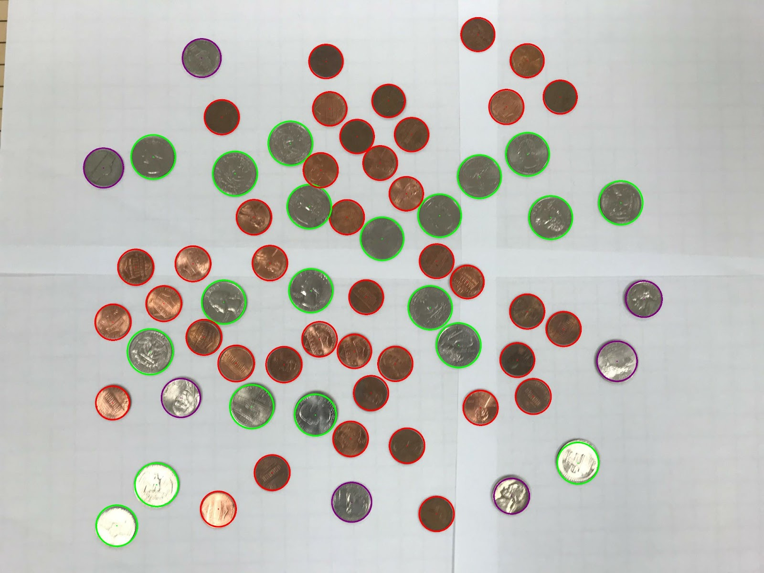

Content of results.txt:

41 Pennies

7 Nickels

0 Dimes

20 Quarters

0 Silver Dollars

0 Gold Dollars

Total: $5.76

1. For the medium image:

Command line including all parameter values used for this image:

./l071 -H 36 -L 30 -F medium.jpg -KS 3 -MS 90 -R 3 -MinR 70 -MaxR 115 -TC 57 -MinQ 102

Initial image:

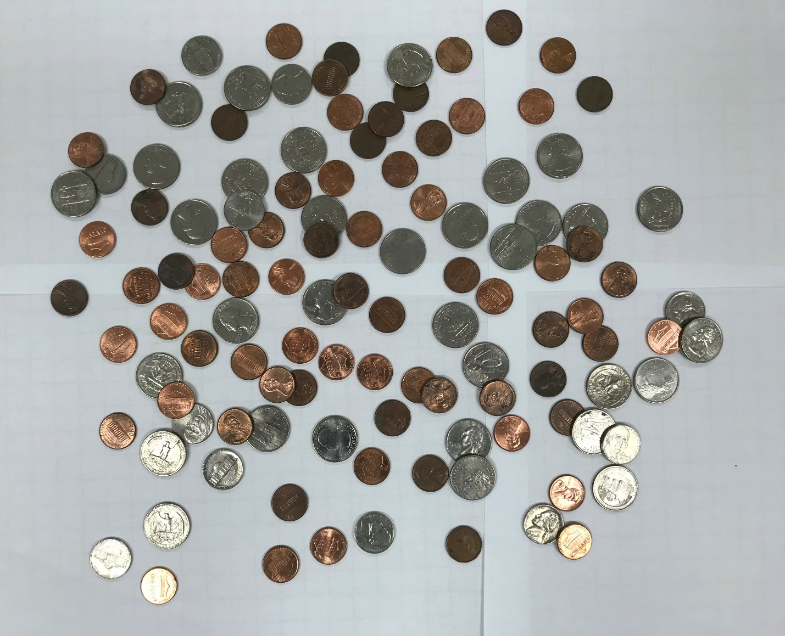

imageg,jpg:

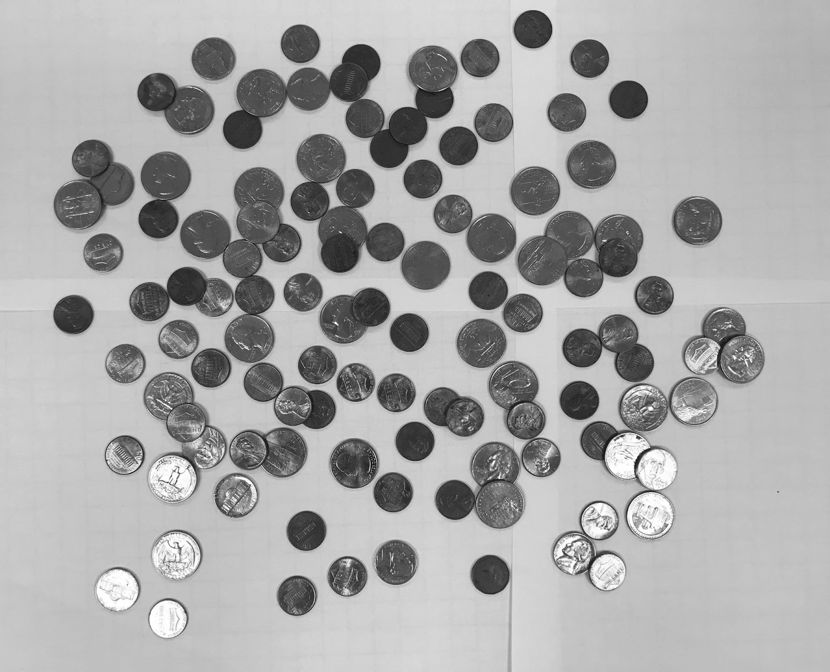

imagef.jpg:

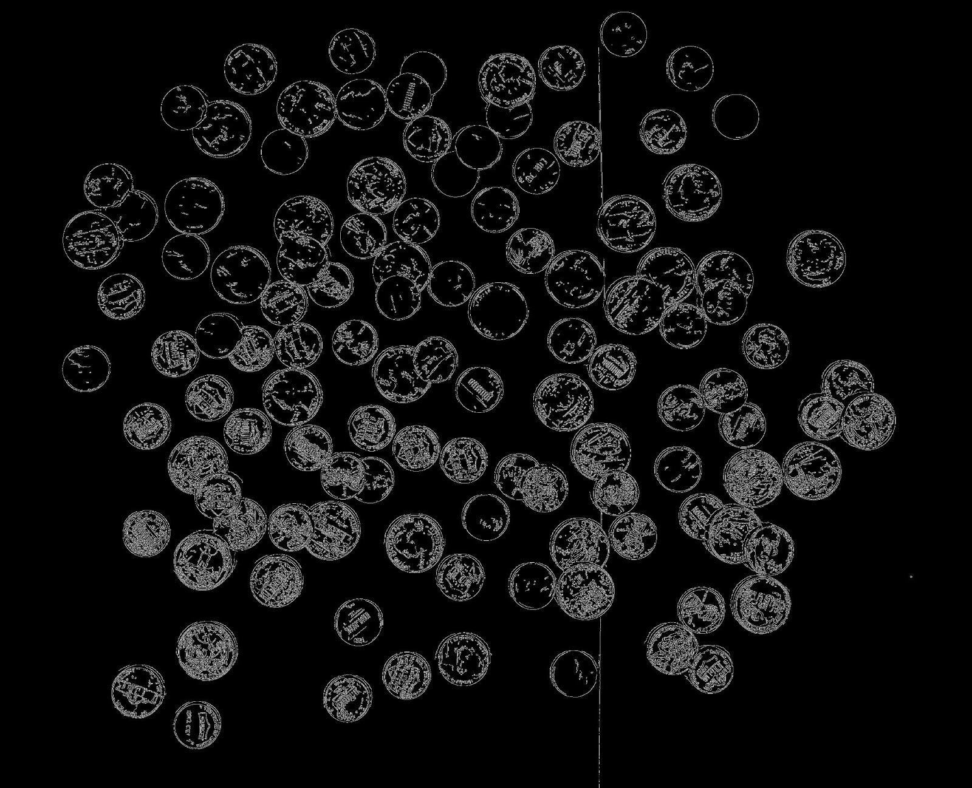

coins.jpg:

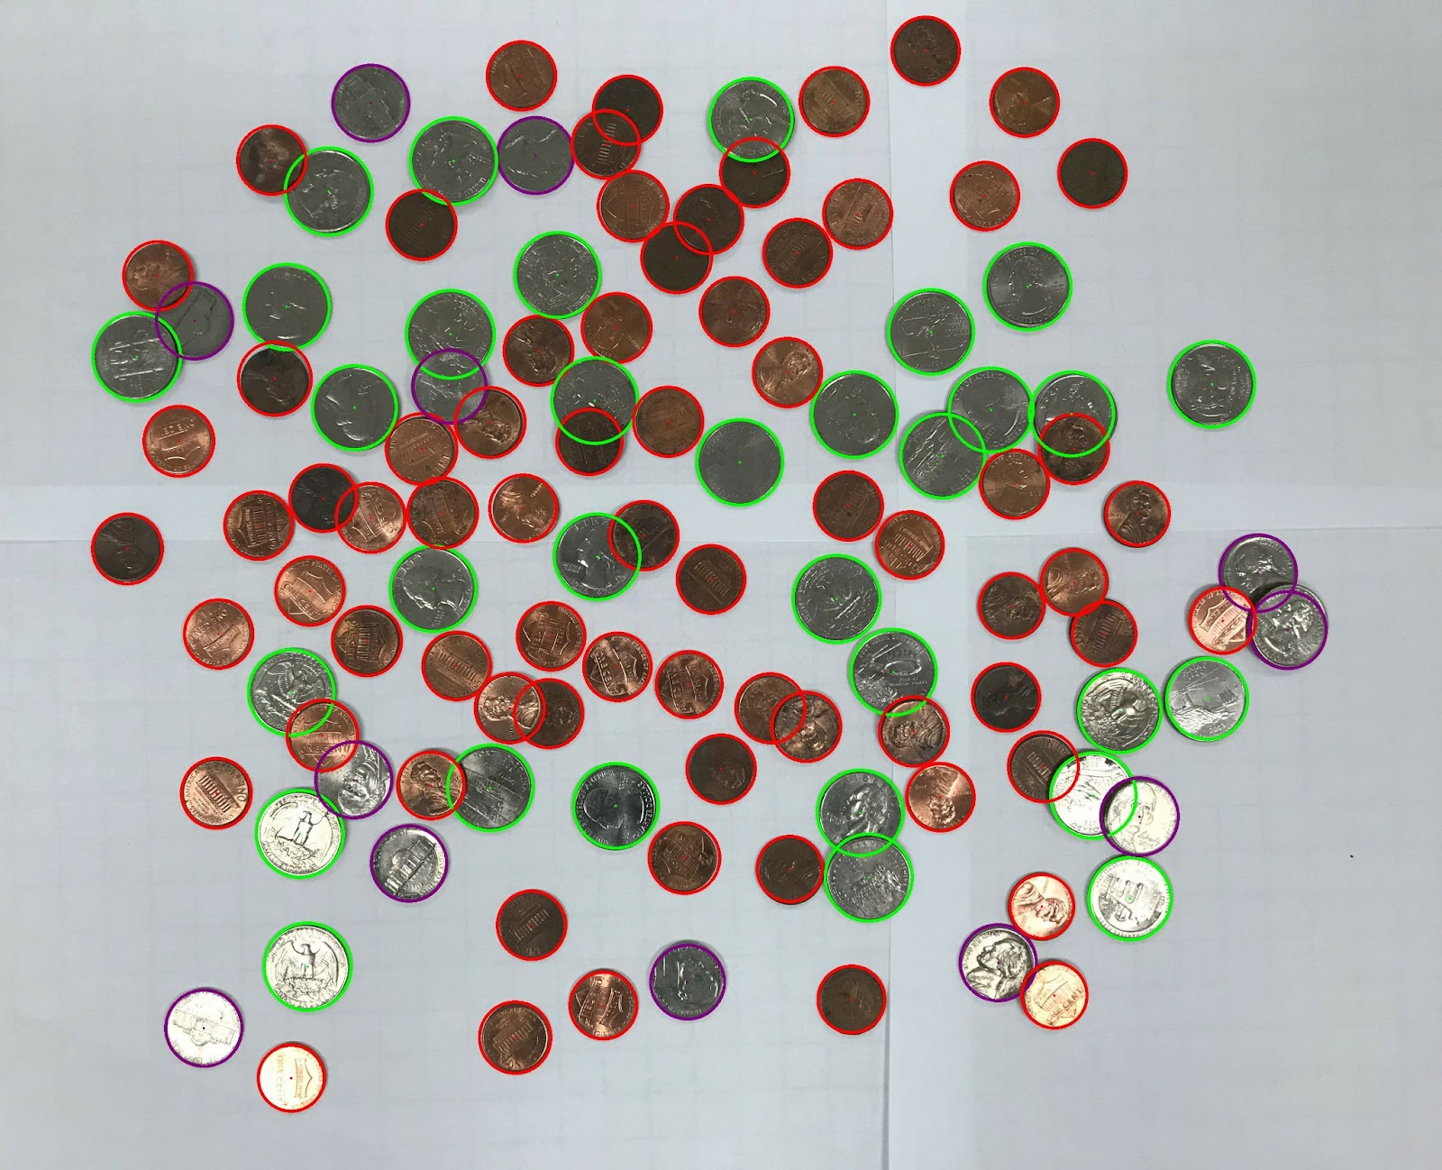

Content of results.txt:

72 Pennies

12 Nickels

0 Dimes

32 Quarters

0 Silver Dollars

Total: $9.32

1. For the hard image:

Command line including all parameter values used for this image:

./l071 -H 36 -L 30 -F hard.jpg -KS 3 -MS 40 -R 3 -MinR 70 -MaxR 170 -TC 60 -MinQ 103

Initial image:

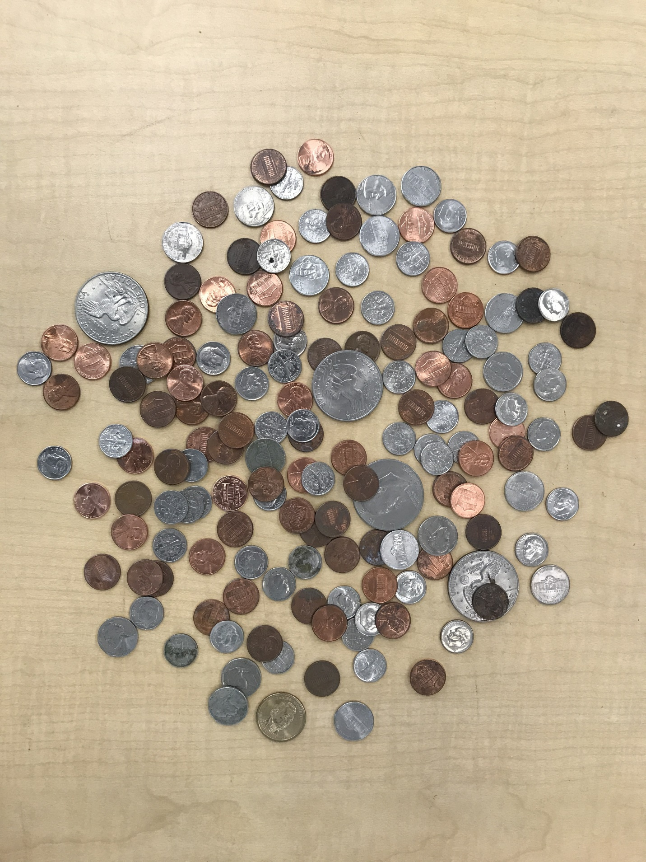

imageg,jpg:

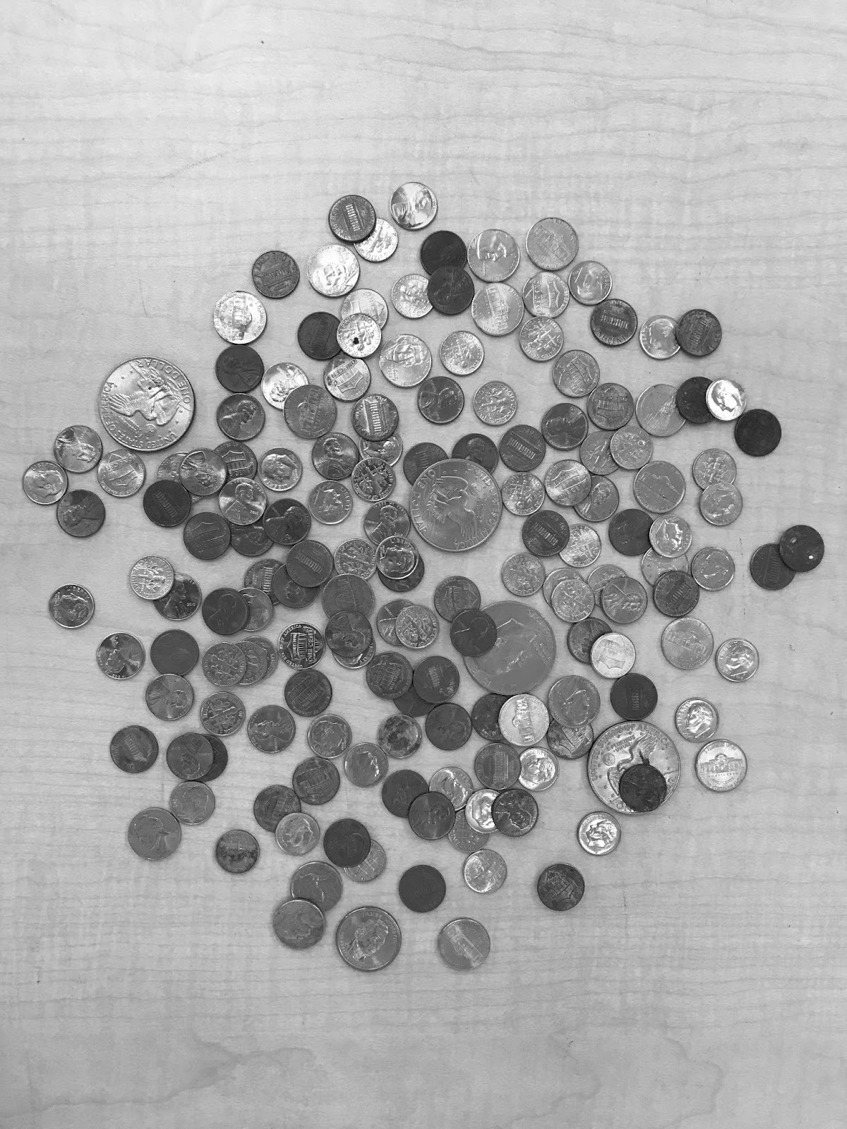

imagef.jpg:

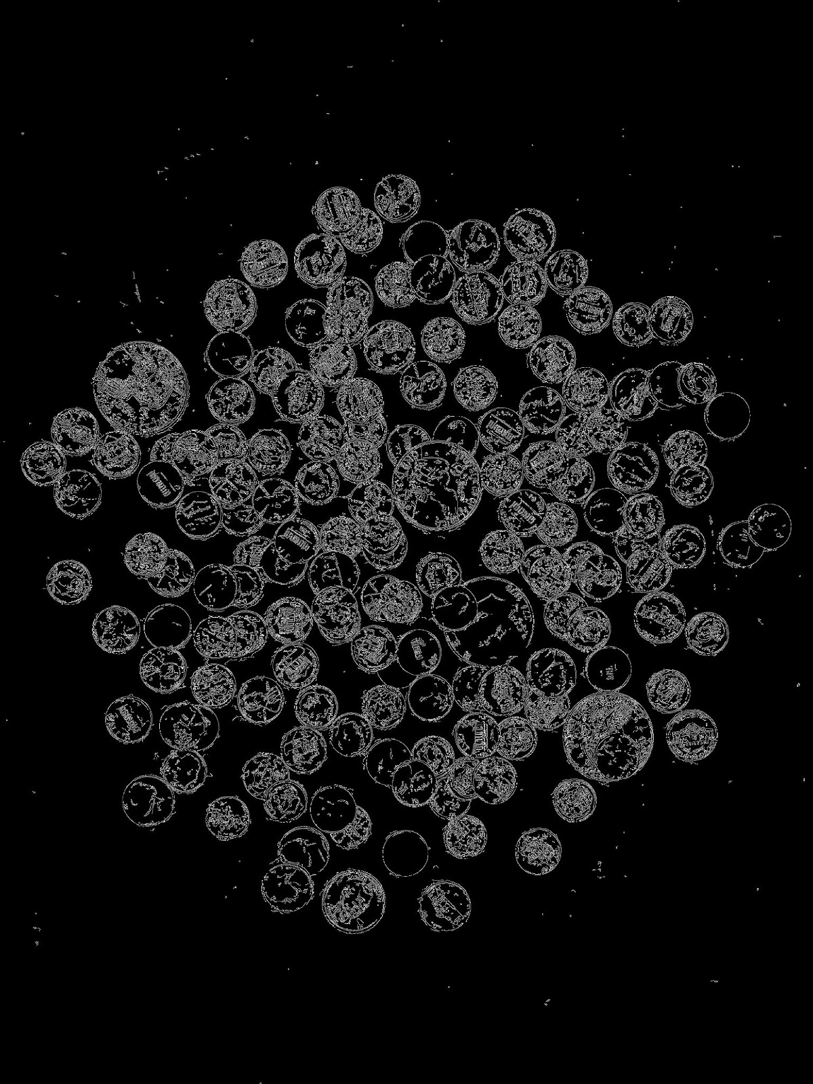

coins.jpg:

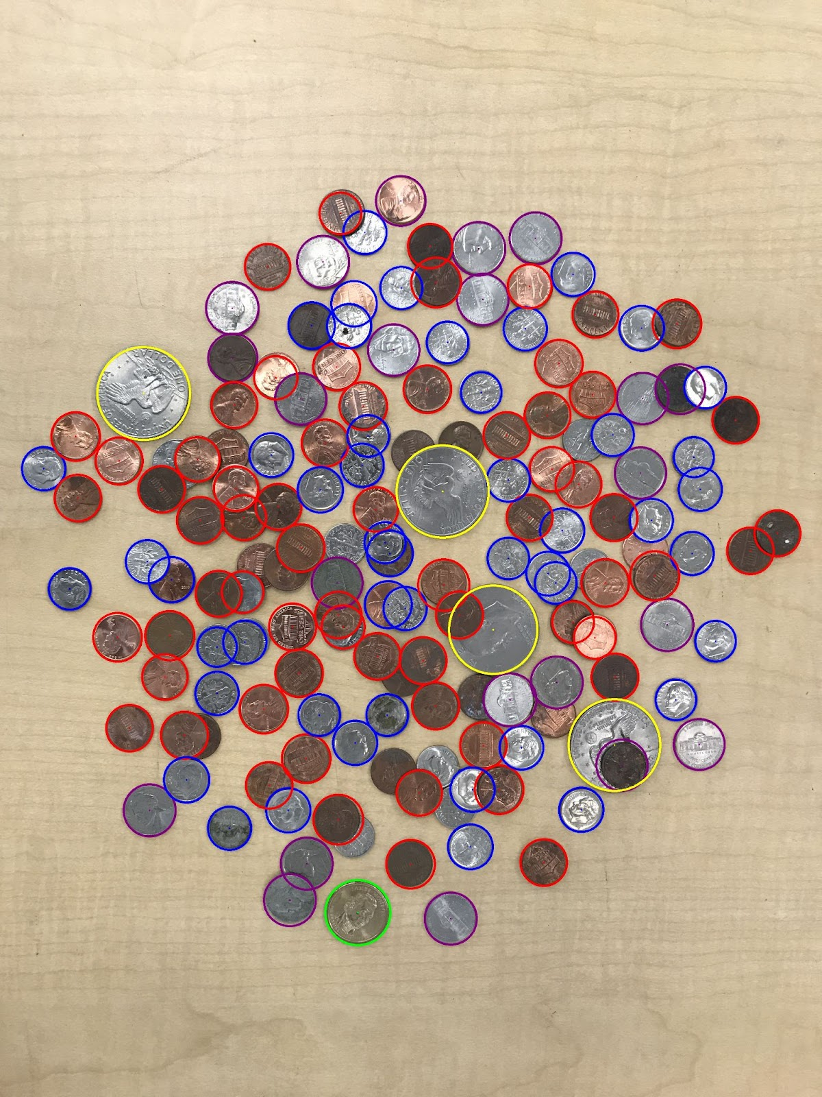

Content of results.txt:

65 Pennies

22 Nickels

48 Dimes

1 Quarters

4 Silver Dollars

Total: $8.8